Graphing Linear Inequalities

|  |  |
| --- | --- |
| Student Learning Objective: | Essential Question: |

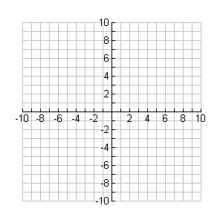Name___________________________________________________ Date___________ Period________

**Bell Work**

Graph the inequality.



**Mini-Lesson (Guided Notes)**

**Recall the steps to graphing linear inequalities:**

**Steps:**

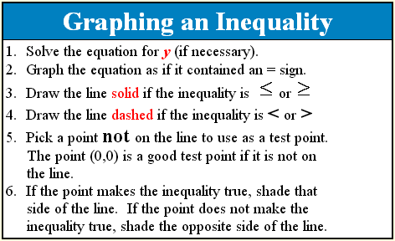

**Work Period**

Complete the Linear Inequalities Shading Investigation below.

****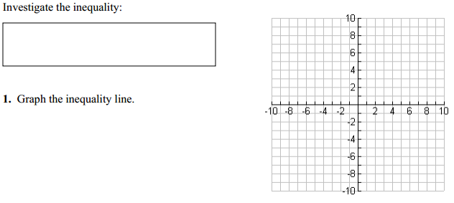

**STOP!** Once you have graphed your line, raise your hand to be checked before moving on

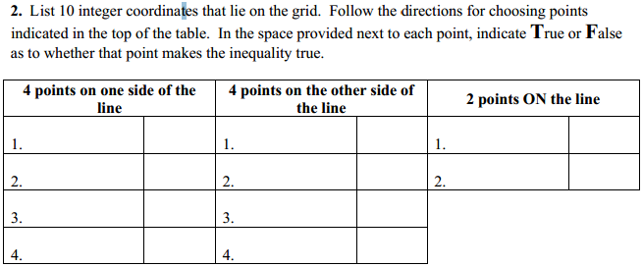

**3.** What does testing the points ON the line tell you about using a solid/dotted line? Explain.

|  |
| --- |
|  |
|  |
|  |

**4.** Based upon your findings in the chart above, shade the graph to indicate where the answers to the inequality lie.

**Closing:**

(Think, Pair, Share)

What makes testing points important when graphing linear inequalities?

What I Will Share:

|  |
| --- |
|  |
|  |
|  |
|  |
|  |

**Regents Prep:**

